POWER BI Case Study – Day 29 -- Keerthi Sivani
Dataset Link -- https://www.kaggle.com/datasets/samolkin/adventure-works-sales

Step 1: Import Dataset
Step 2: Transform the Data, because in sales the data is categorize into years like 2020 in one table, 2021 in another table, 2022 in another table
By Using Append query all the sales comes into one table
Step 3: Load the Data
Step 4: In these step we are modeling the data (Data Modeling), make connections to Fact Tables to Dimensions Table
- Fact Sales -> DimProduct (Connection based on Product Key)
- Fact Sales -> DimCustomer (Connection Based on Customer key)
- Fact Sales -> DimTerritory (Connection based on Territory Key)
Mark as Date Table -> Modelling -> Mark as Date Table -> Select Date Column
Step 5: Creating DAX Measures
- Created a Measure : Total_Revenue
Find the total revenue we have product Cost, but in FactSales Table we don’t have a product cost then again Transform Data -> Merge Queries (based on ProductKey) -> it will add all columns -> In that I have Product Cost (Cost price) and Product Price (Selling Price)

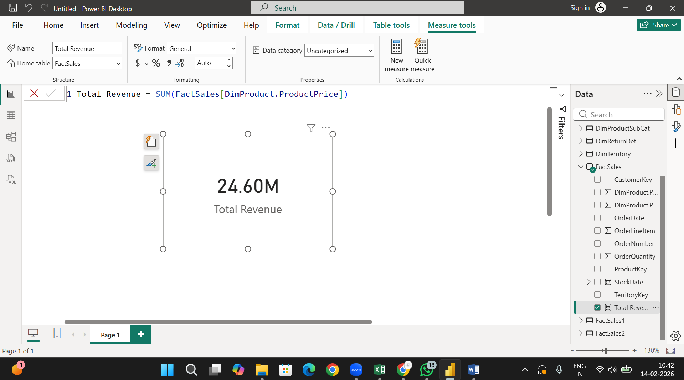

2. Created a Measure: Total Orders

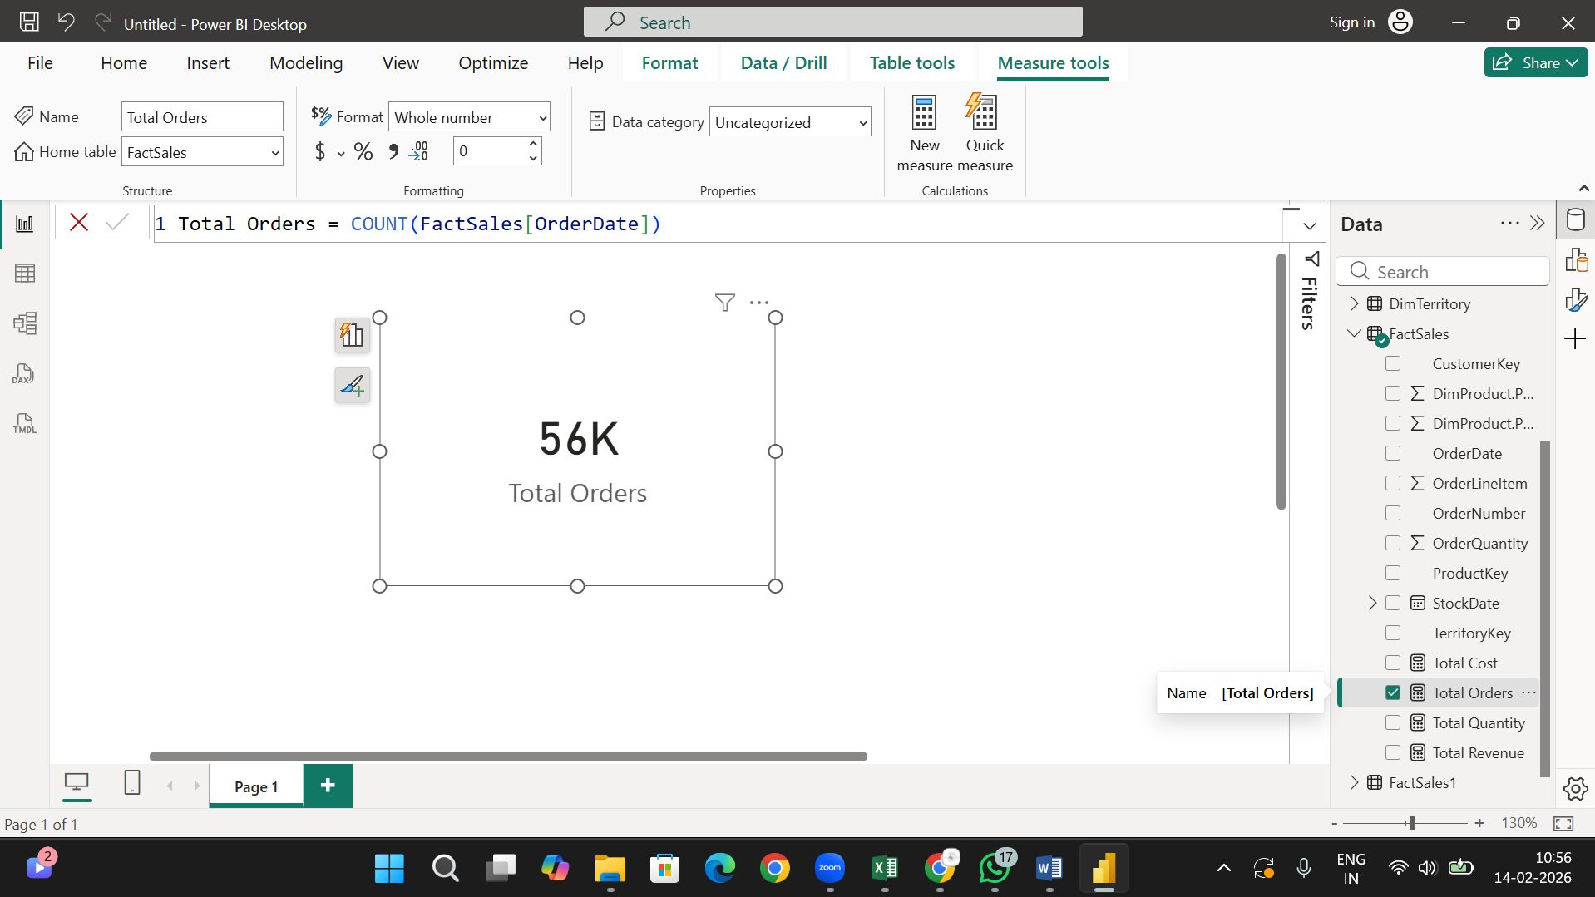

3. Created a Measure: Average Order Value

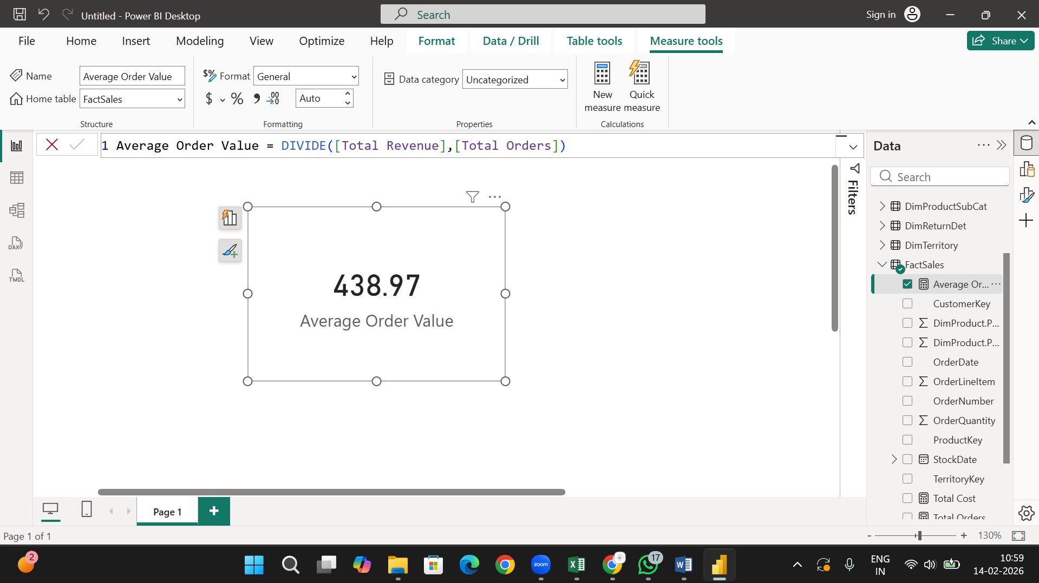

4. Created a Measure: Profit Margin %
Profit = total revenue – total cost

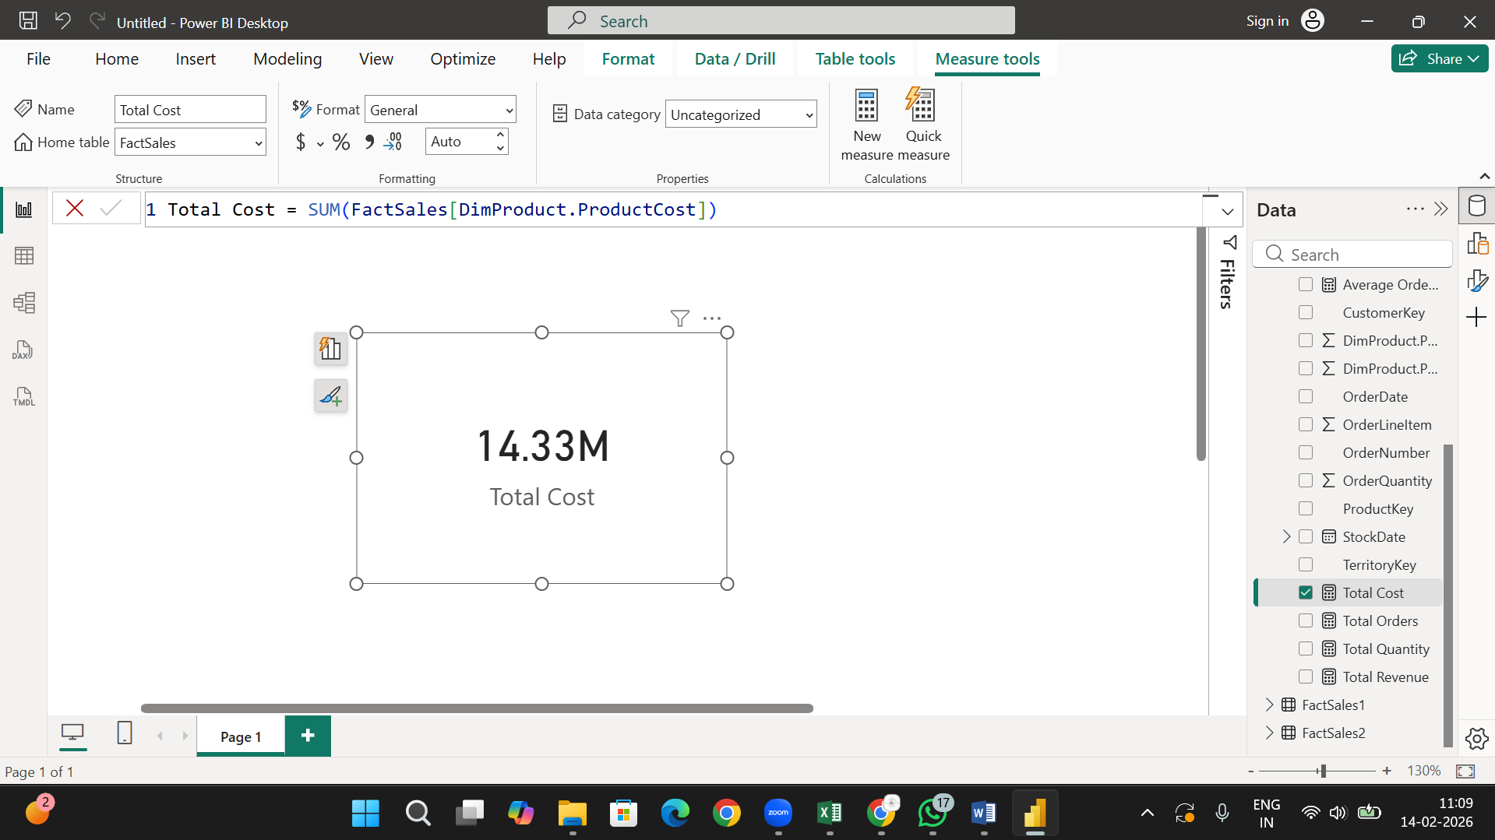

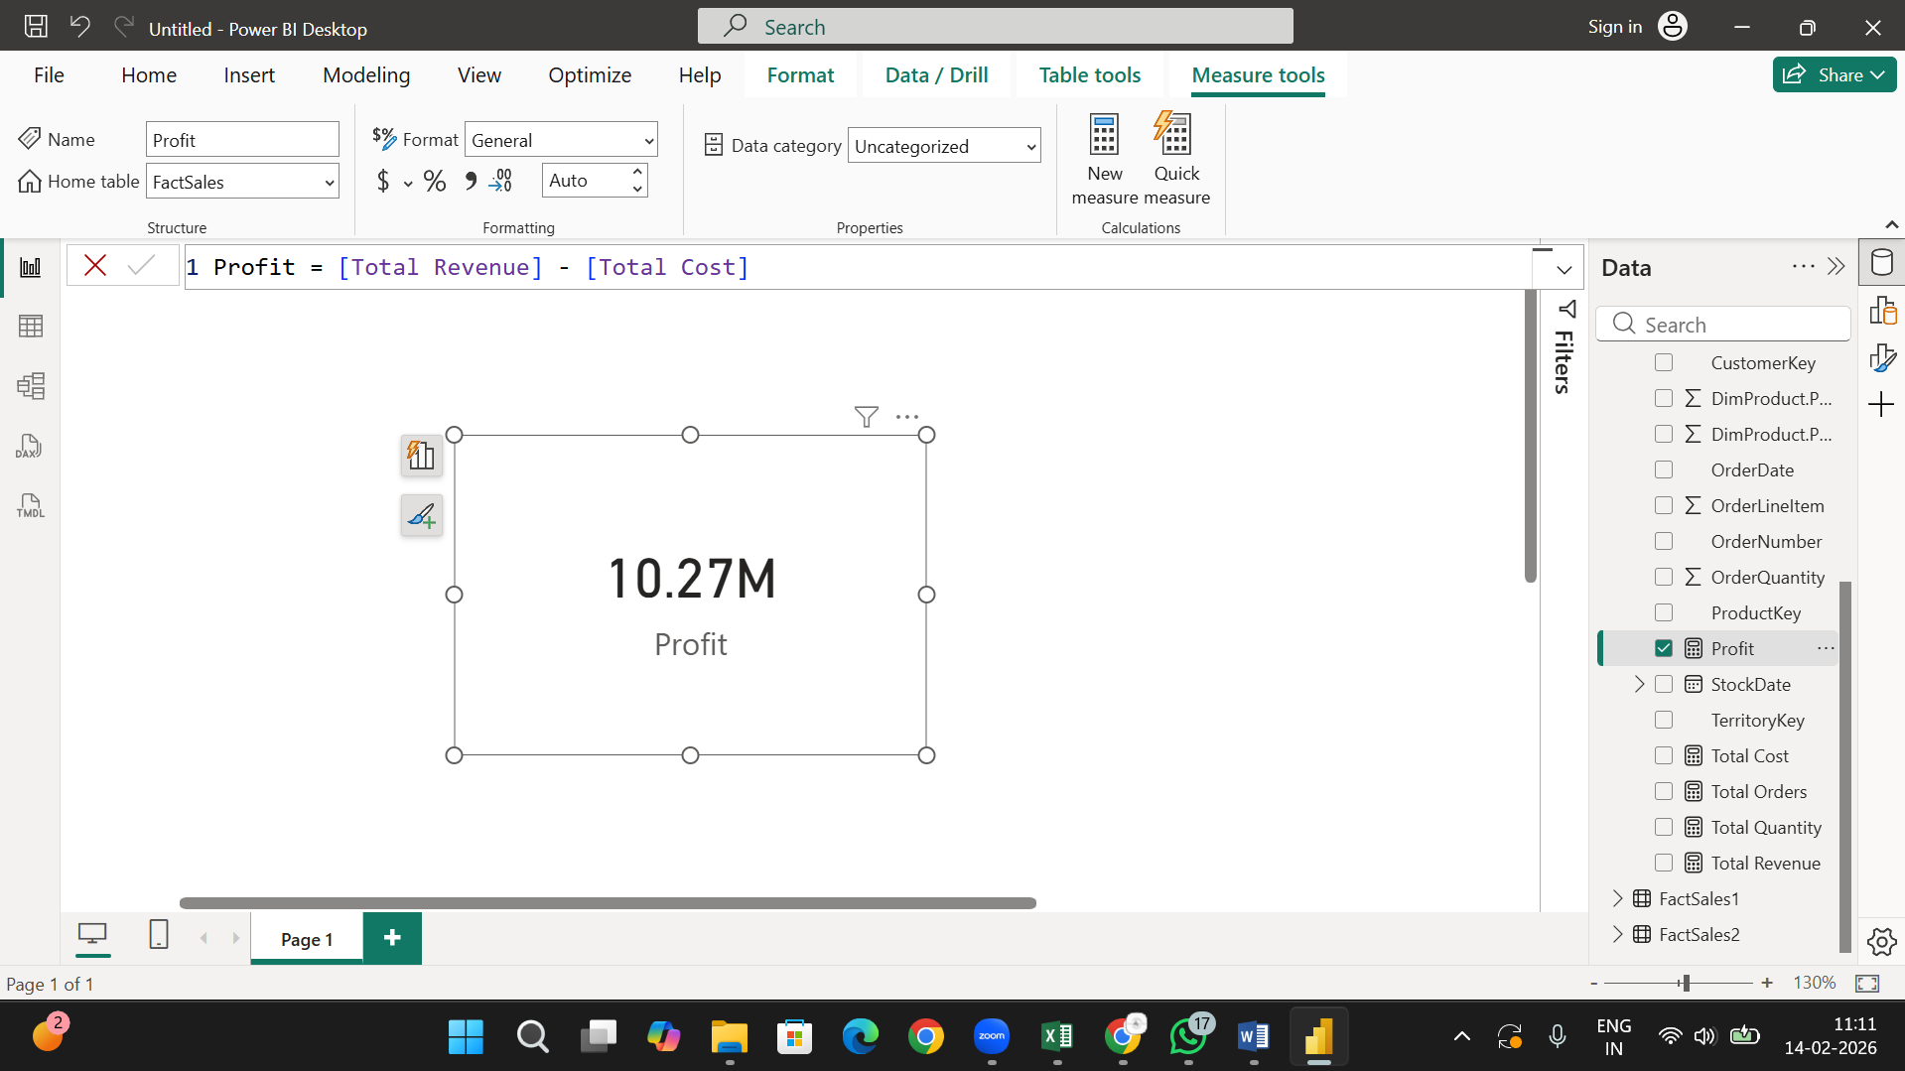

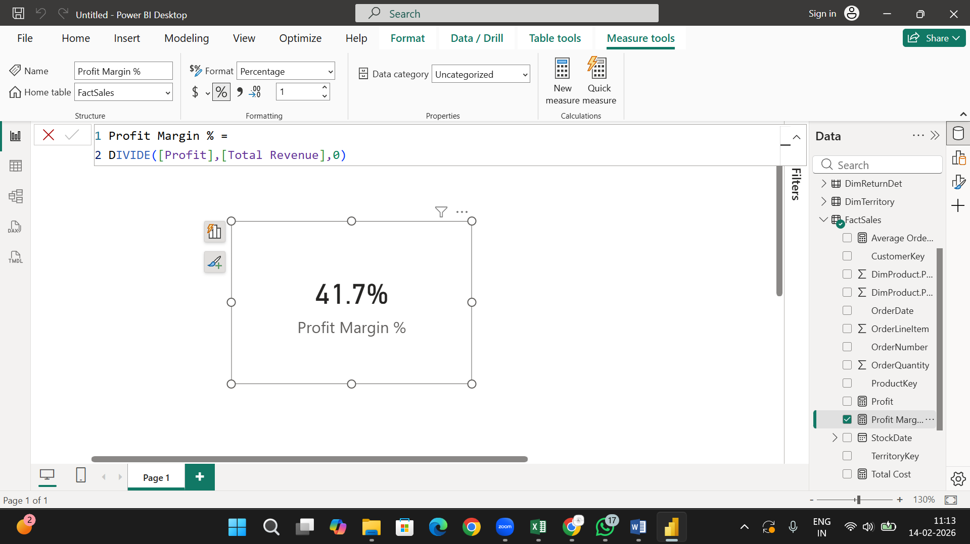

Step 6: Visualizations

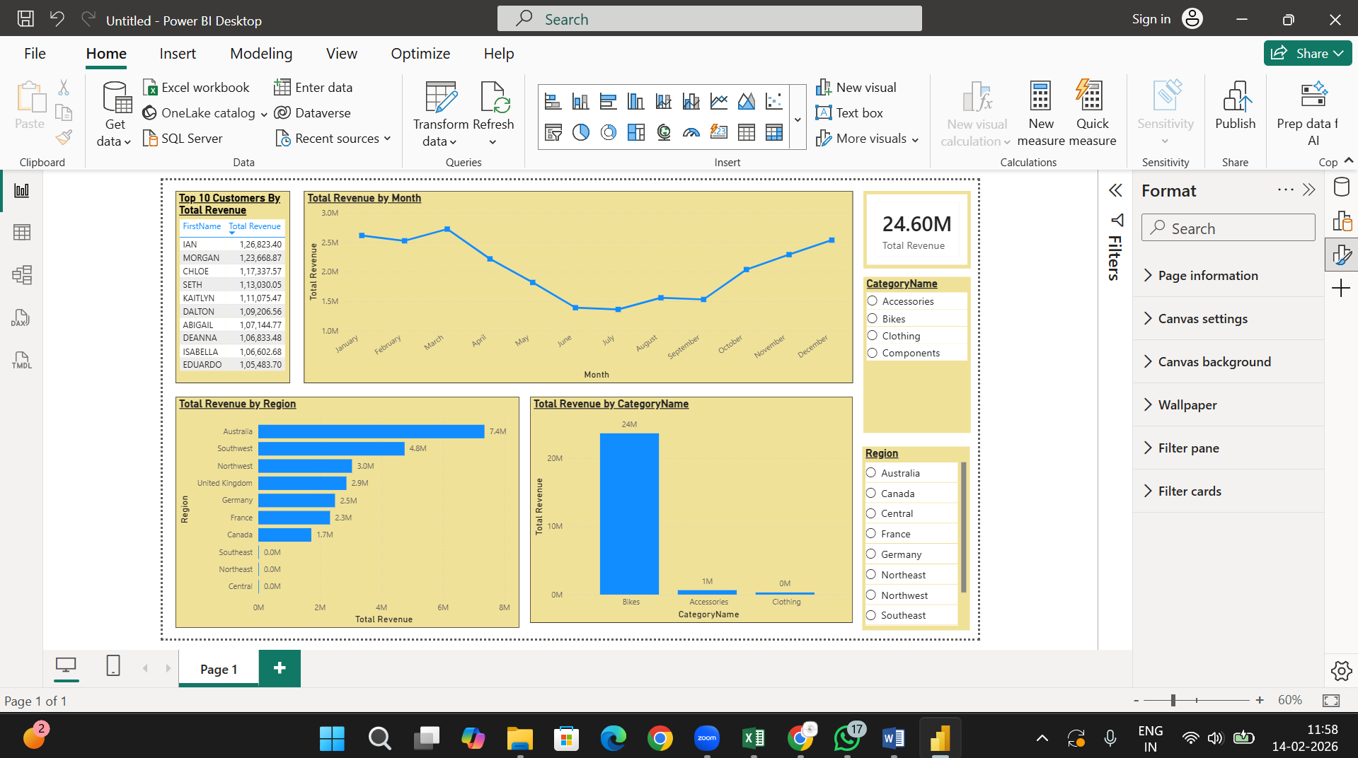

Step 7 : Insight Generation
- Regional Performance

Australia is the strongest market contributing the largest share of revenue (7.4M). However, multiple regions are underperforming, indicating untapped market potential.

Australia – 7.4M (Highest revenue contributor)
Followed by:
- Southwest – 4.8M
- Northwest – 3.0M
Underperforming Regions:
    - Central
    - Northeast
    - Southeast
- Product Analysis
Revenue is highly concentrated in one category (Bikes).
Heavy dependency on one product increases business risk.
- Customer Analysis
Top 10 customers contribute significant revenue
Highest individual customer revenue ≈ 1.2M+
- Trend Analysis

Strong performance in Jan–March
Decline in April–June
Recovery from October–December
December shows strong growth

Business shows seasonality pattern.

